Table of Contents:

Logline & Synopsis Page 3
Crew Bios Page 3
Cast Page 4
Motivation Page 5
FAQs Page 5
Production Stills Page 6
Credits Page 10

Logline:
Homelessness is uncomfortable to acknowledge. It makes us feel emotions we prefer to avoid and leads us to look past people rather than into them. Meet the youth that have experienced years as homeless teenagers under the radar of their own community.
Synopsis:
‘404 Not Found’ holds double meaning for the youth homeless population in Manchester. It is street code for the youth center, a reference to its old address; also, it references an internet code for a webpage not found, as these youth are the most difficult homeless population to locate. Whether they are escaping abusive situations, fearful of the foster care system or rejected by their own families, they often hide from those who would help them and those who would hurt them alike. The youth interviewed have all experienced multiple years as homeless teenagers under the radar of their own community.
Crew Biographies:
Jasmine Inglesmith - Director
Jasmine Inglesmith started taking “photographs” with her hands sitting in class when she was in the third grade. Since then she has made a name for herself on the seacoast through a wide range of talents that include wedding photography, social media management for local businesses, music videos, and photojournalism. Her photography has been featured in the Portsmouth Herald, The Sound, The Square, and New Hampshire Magazine.
Nancy Phillips – Producer
Nancy Phillips has worked in the auto industry for over 25 years. Children’s welfare has been a lifelong focus and an integral part of her business, leading her to co-found, along with the NH Auto Dealers Association, the program ‘Kids and Company’ which was implemented in over half of the state’s elementary schools and was responsible for training hundreds of teachers, social workers and police officers. She has also served as a volunteer and board member for Court Appointed Special Advocates for children and recently formed Cars for CASA, a financial support group for the organization.

Maggie Wallace – Screenwriter
Maggie Wallace is a journalist and writer who loves to interview locals from her native New Hampshire. With a dual focus on travel writing and local journalism, Wallace strives to find common ground between ‘away’ and ‘here,’ and to find stories that connect people. Publishers such as Backpacker, The Trek, Matador Network, The Sound, The Square, and New Hampshire Magazine have featured her writing.

Cast:
Jasmine Inglesmith Director of Photography
Nancy Phillips Producer
Maggie Wallace Screenwriter

STARRING
Gabrielle Bouchard
Courtney DeFrancesco
Kadyja Harris
Kasadye McClaren
Damien Marcel Sebastian

FEATURING
Paul Apple Attorney
Devon Chaffee Executive Director of American Civil Liberties Union NH
Mason Dunn Professor at University of NH
Jude Flynn Humanitarian
The Honorable Ted Gatsas Mayor of Manchester, NH

ADVISOR
Kat Strange CFS Communications Director
CHILD AND FAMILY SERVICES
Kate Dargan UNH Intern
Erin Kelley Program Director
David Harris Case Manager
Jodi Lynn Hartke Outreach Social Worker
Carol Heald Program Manager
Mandy Lancaster Program Manager
Allison Ritter Case Manager

MUSIC BY

George Winston Part 1: Snow
Bone Fragments The Boneyard
Breakfast Song Birdsnest
Blake Seale Movie Ambient 2
Breakfast Song Honey Bee
Maeve Moller-Mullen and Jay Kelly Sunny
The Farthest Force I Hold You Dear
David Wax Museum The Rumors are True

Background information & Motivation:
The purpose of this film is to give a real face to youth homelessness. Homelessness is uncomfortable to acknowledge. It makes us feel emotions we prefer to avoid and leads us to look past people rather than into them. This film aims to show people that a 17 year old can look like an adult, that the kid ringing up your groceries may not have a home to return to when their shift is over, or that the person you see huddled under a bridge in winter could be a student in your child’s class.
The women involved in this film’s production had never produced a film before but through individual experiences of their own were determined to shine a light on the youth homeless issue in our community. Each member of this team has spent hours with Child and Family Services, traversing lonely woods and city streets, interviewing young people with no place to call home. From this, their small video project grew into a real documentary and a voice for an invisible population. ‘404 Not Found’ is the result of their collaboration.

FAQs:
Child and Family Services - provides a continuum of programs for young people who are experiencing homelessness. www.cfsnh.org
404 Not Found Website – http://www.404notfoundfilm.com

Production stills:
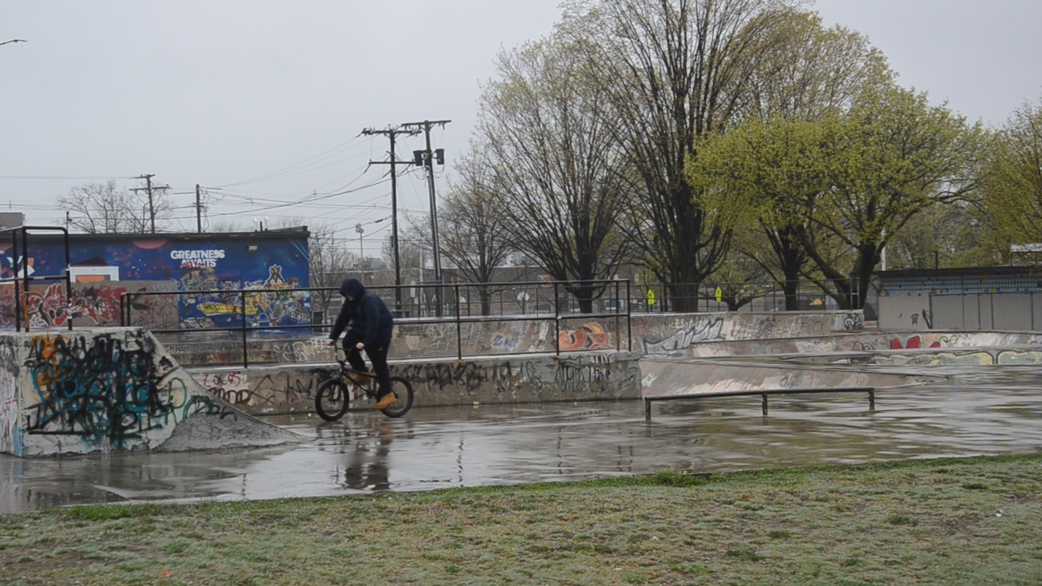
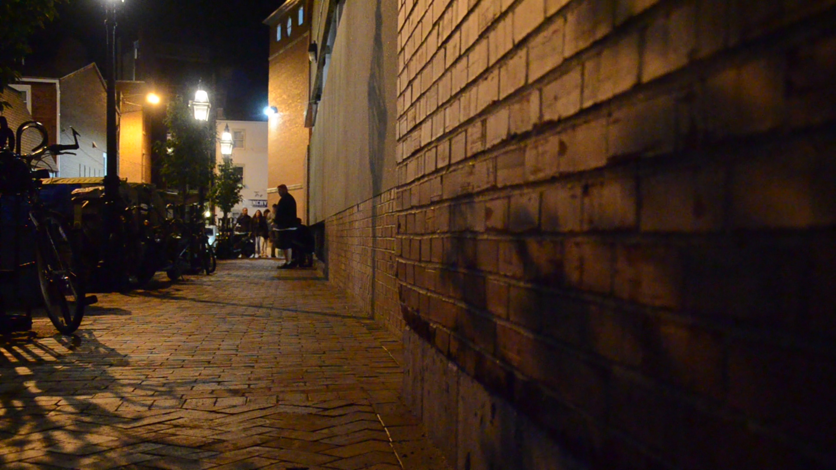
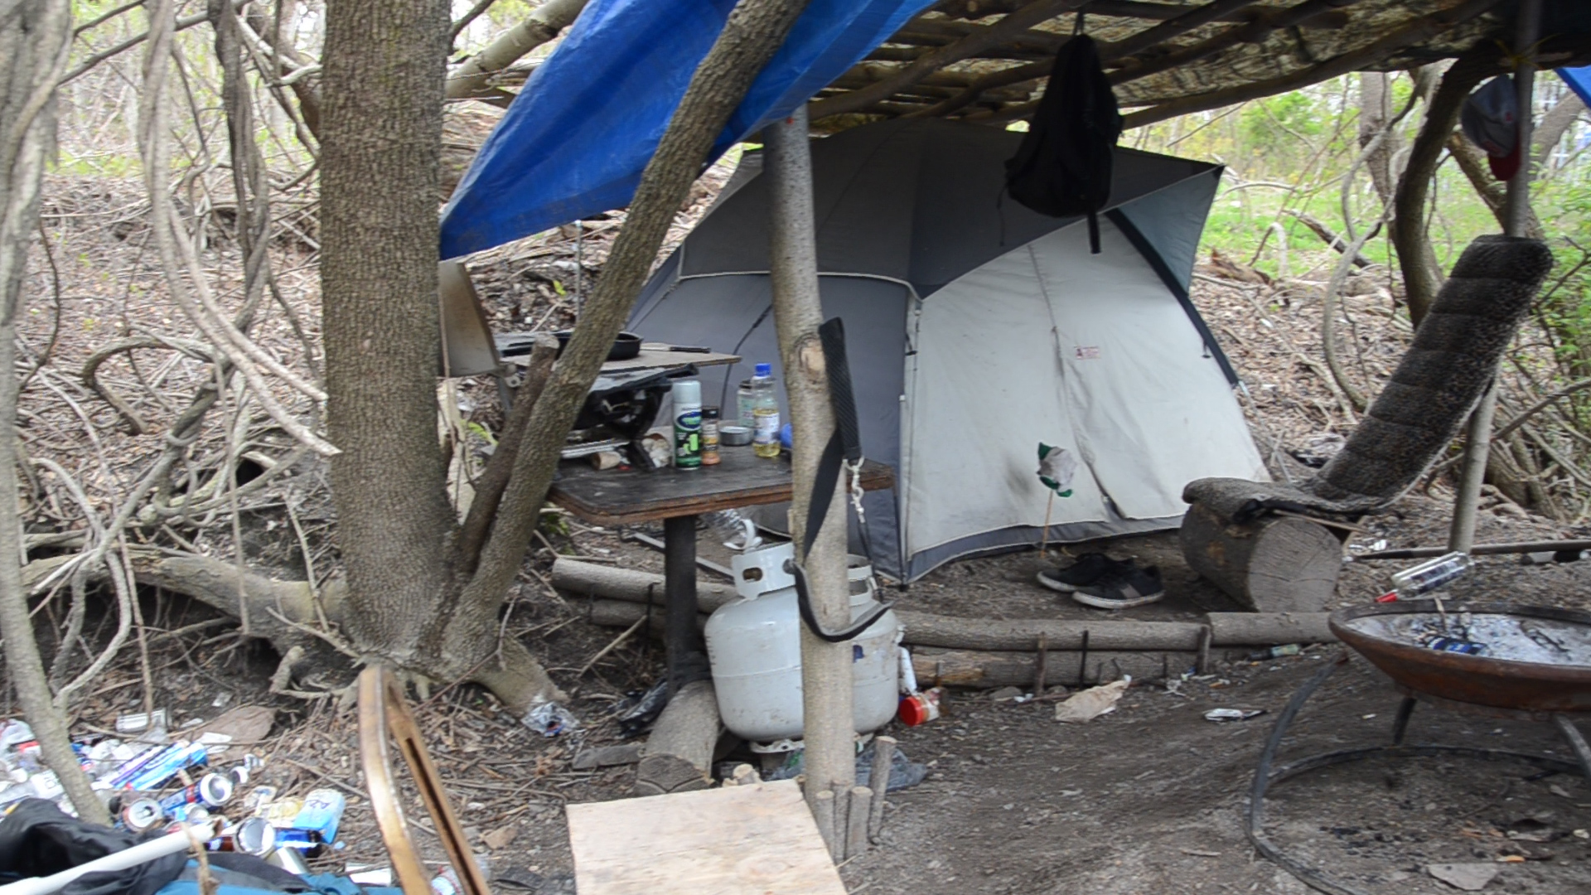
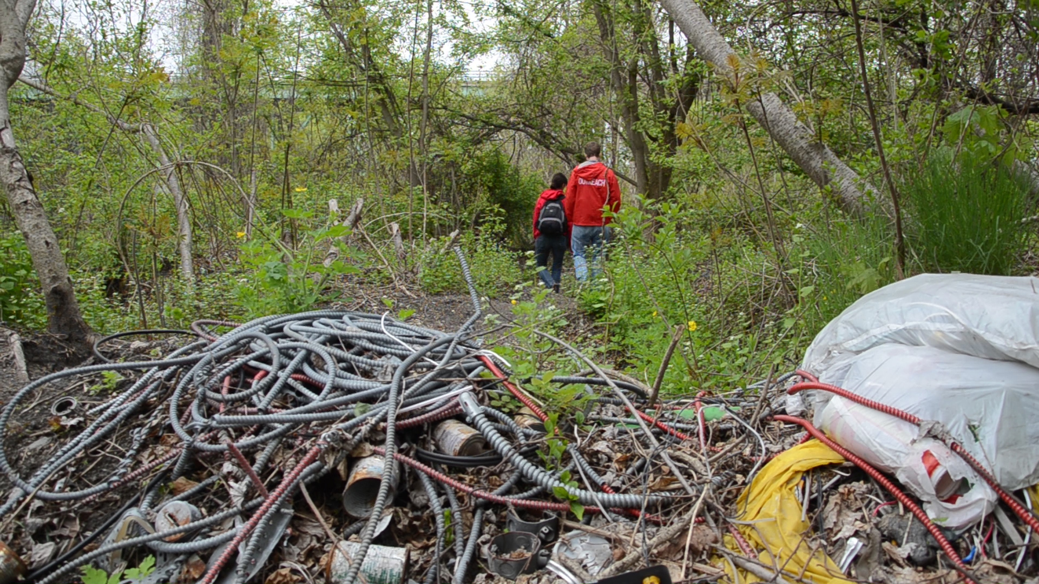
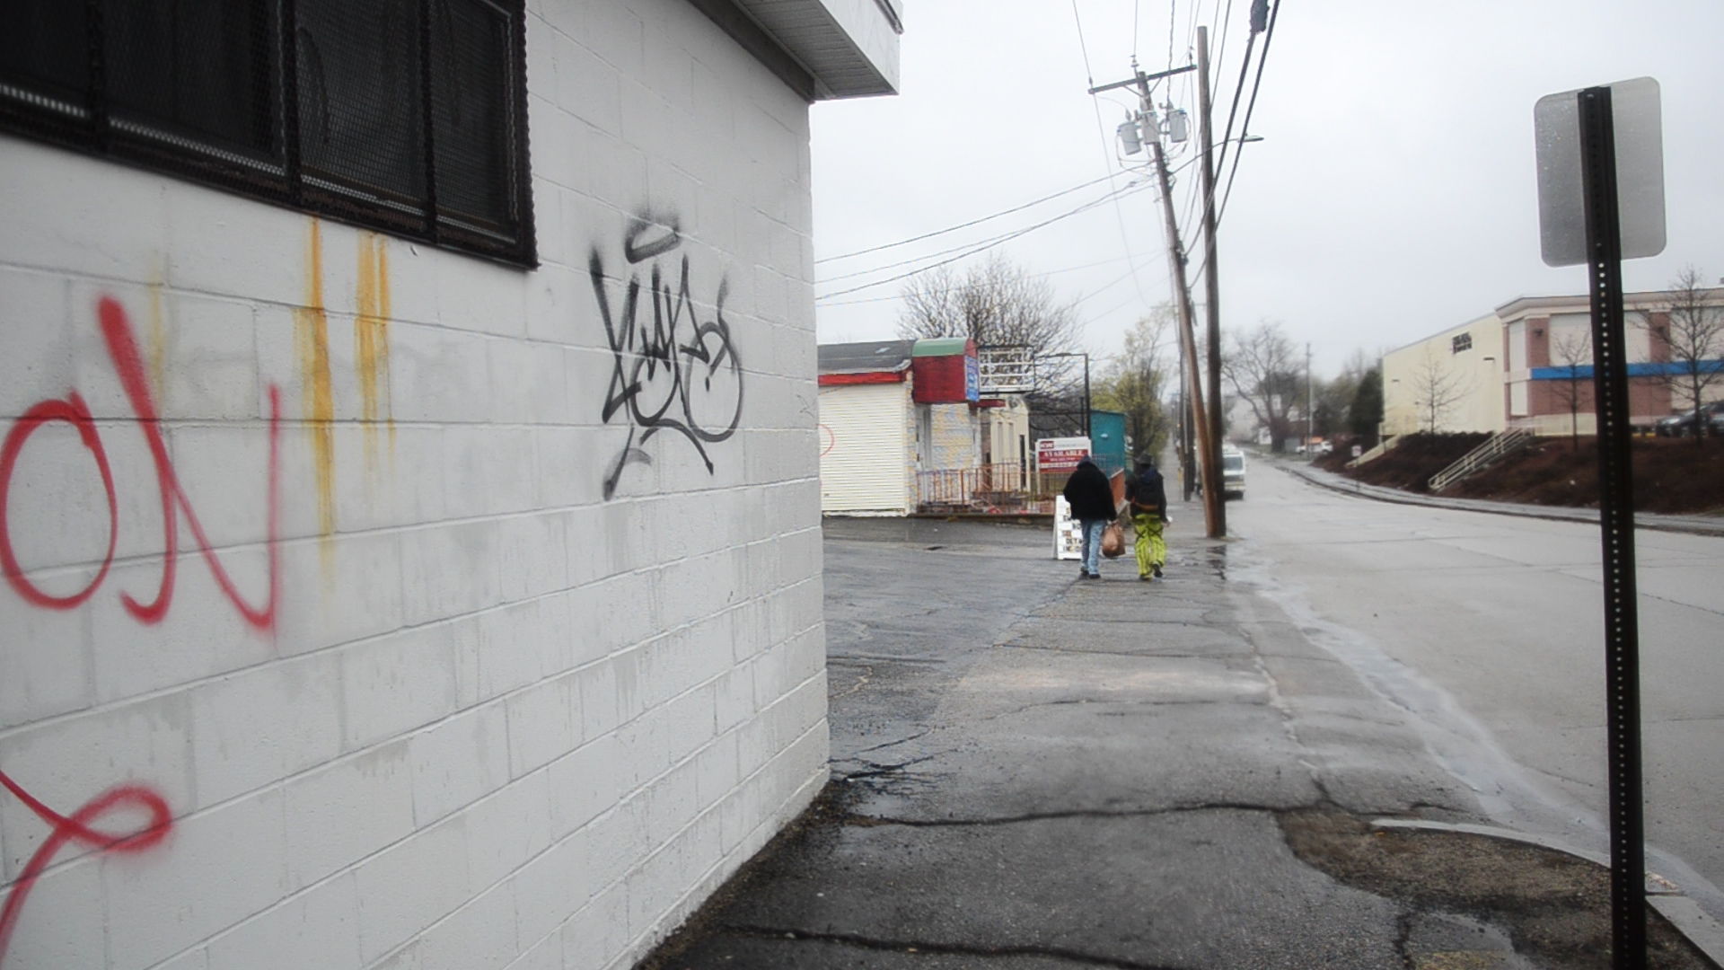

Credits:
Thanks to the musicians who donated songs for the making of this documentary:
George Winston
Colin Deyman and Christine Chapman
Seth Gooby and Isis Alis-Gooby
Blake Seale
Maeve Moller-Mullen and Jay Kelly
Peter Squires and Anne Marple
Suz Slezak and David Wax

Thanks to those that have supported the creation of this documentary and creative assets:

David Anderson
Alexandra Berkowitz
Mark Santoski

Special thanks go out to Mayor Ted Gatsas of Manchester, NH as well as Professor Mason Dunn from the University of New Hampshire

